Unit 4 – Blockchain and Decentralized Applications
Lab 4 Manual
Introduction to Solidity Programming with VS Code and Truffle
Objective:
In this lab, students will learn, implement and integrate the real-world use case of mappings, structs, and functions to create more complex data management structures, enabling scalable and efficient data handling.
By the end of this lab, students will:
- Understand mappings and how they store key-value pairs in Solidity.
- Learn how structs are used to group related variables.
- Explore combining mappings with structs for more complex data management.

- Create a contract to store and retrieve messages, showcasing memory vs. storage usage.
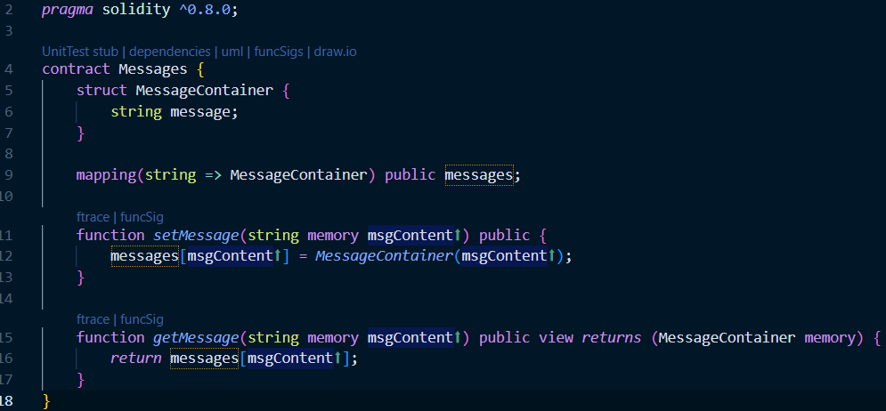

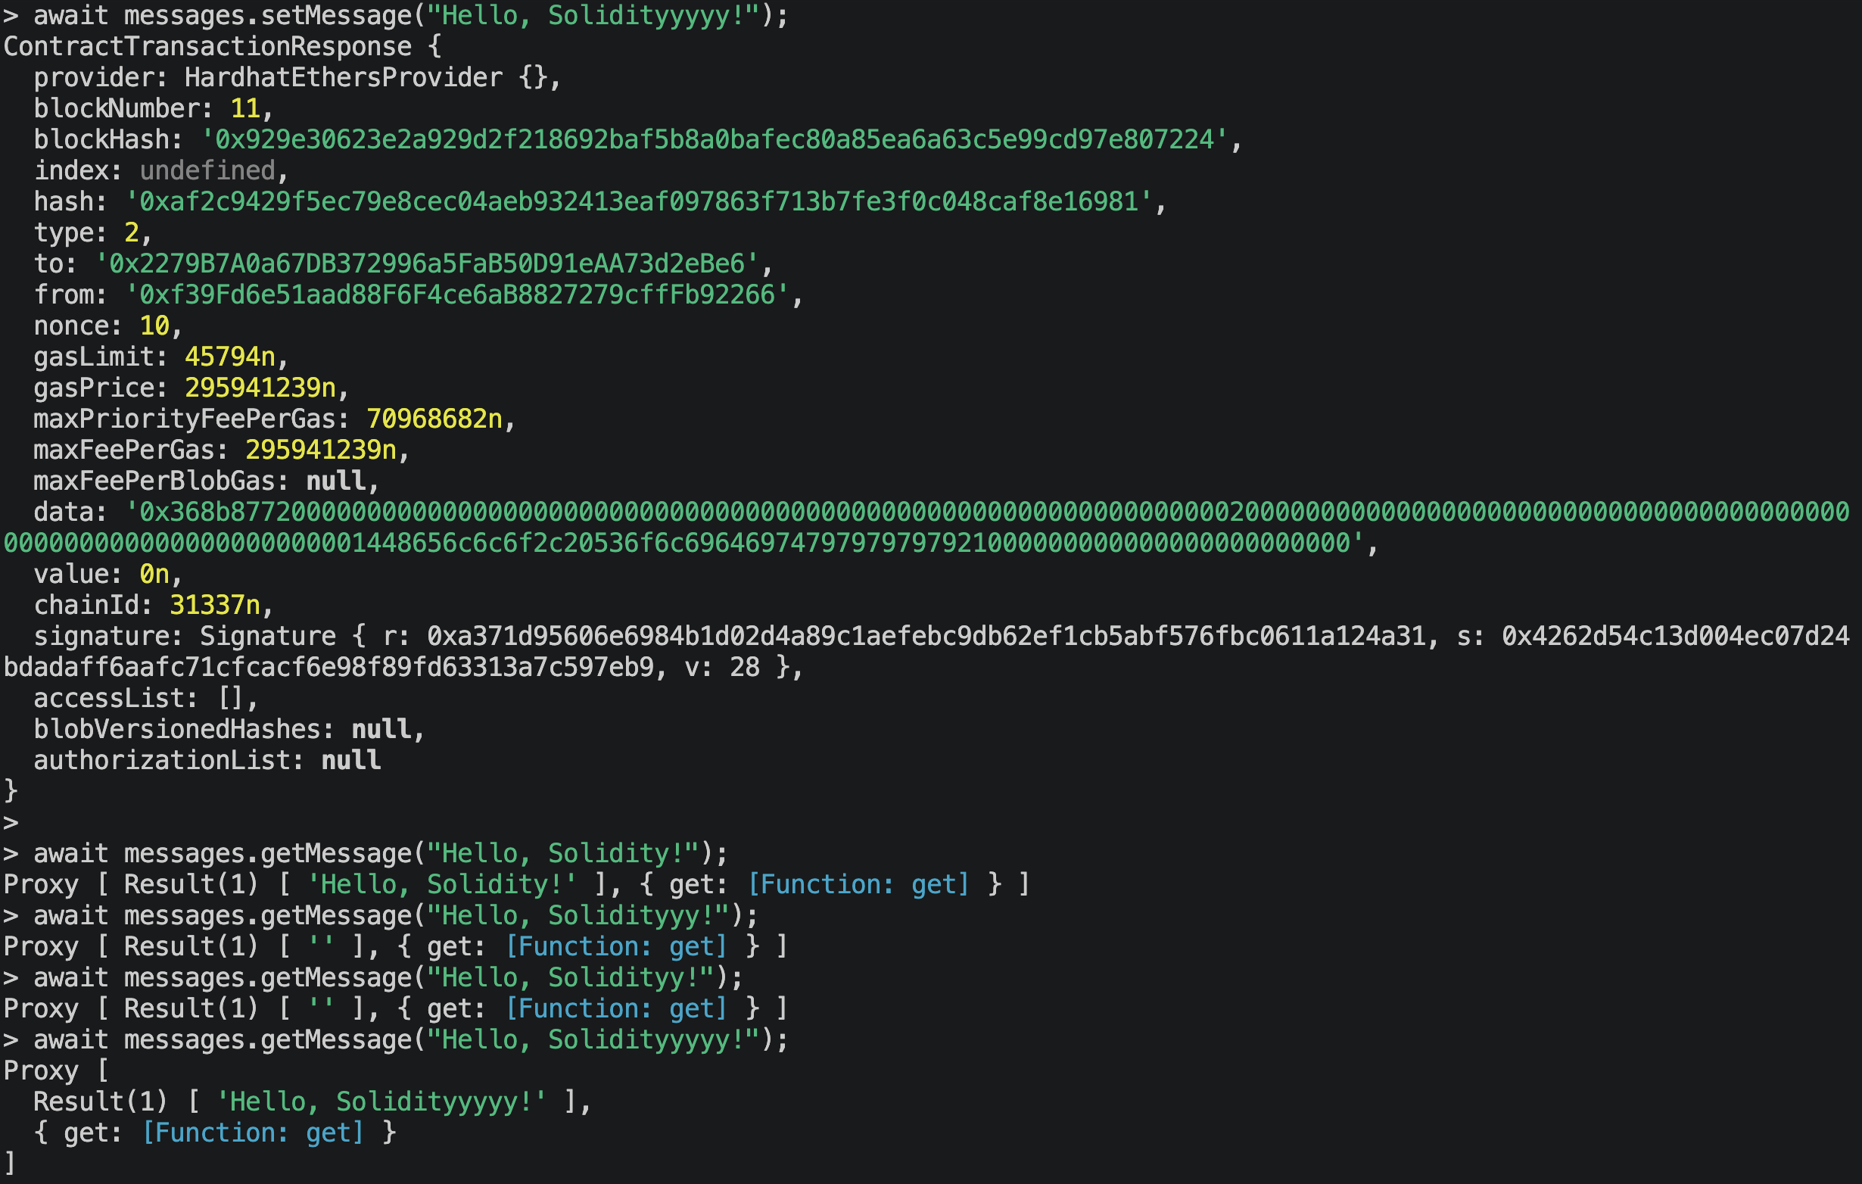

- Develop a contract to represent a person’s information and retrieve it.
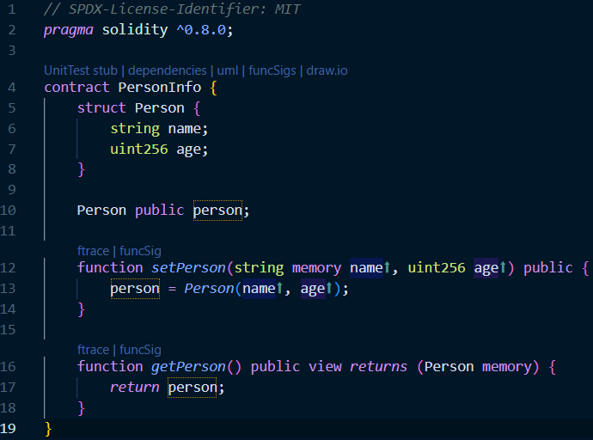
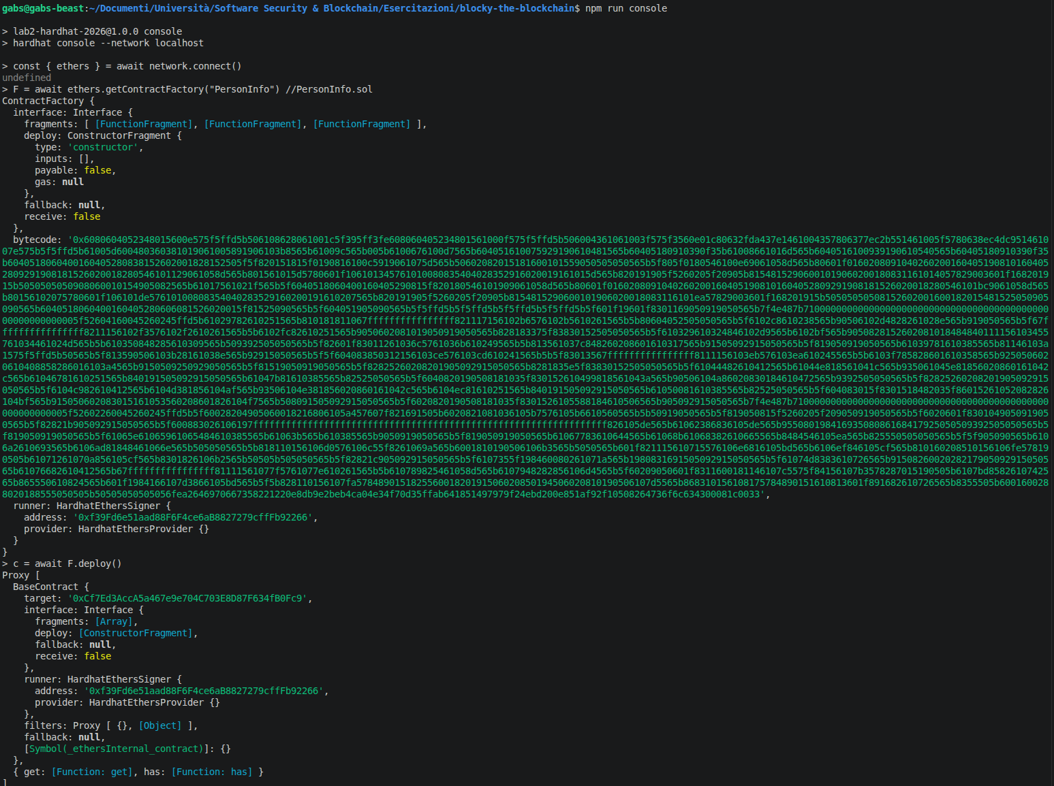
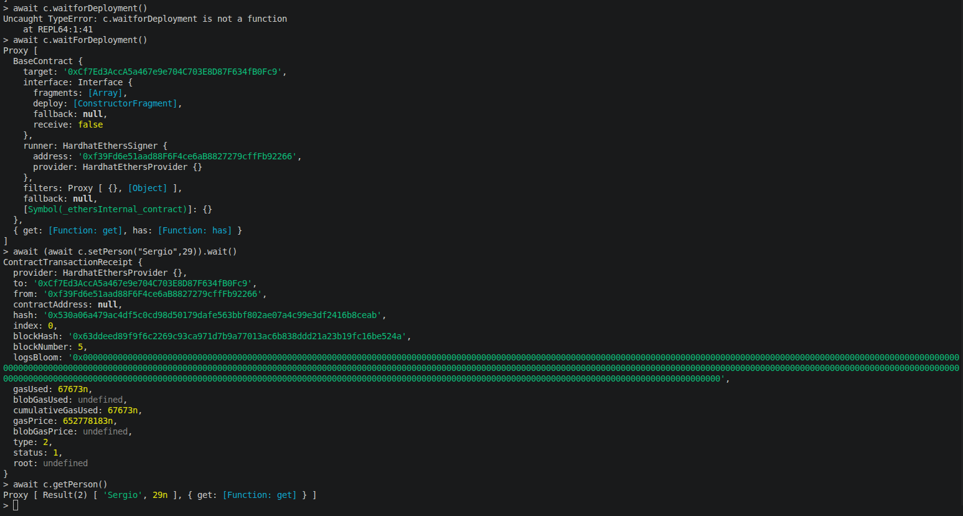

- Demonstrate how to use an array of structs to manage multiple records.
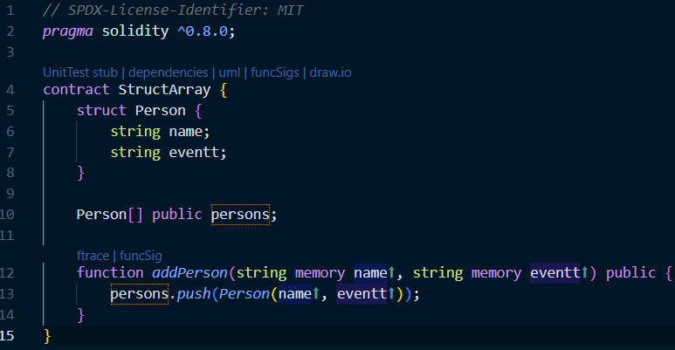
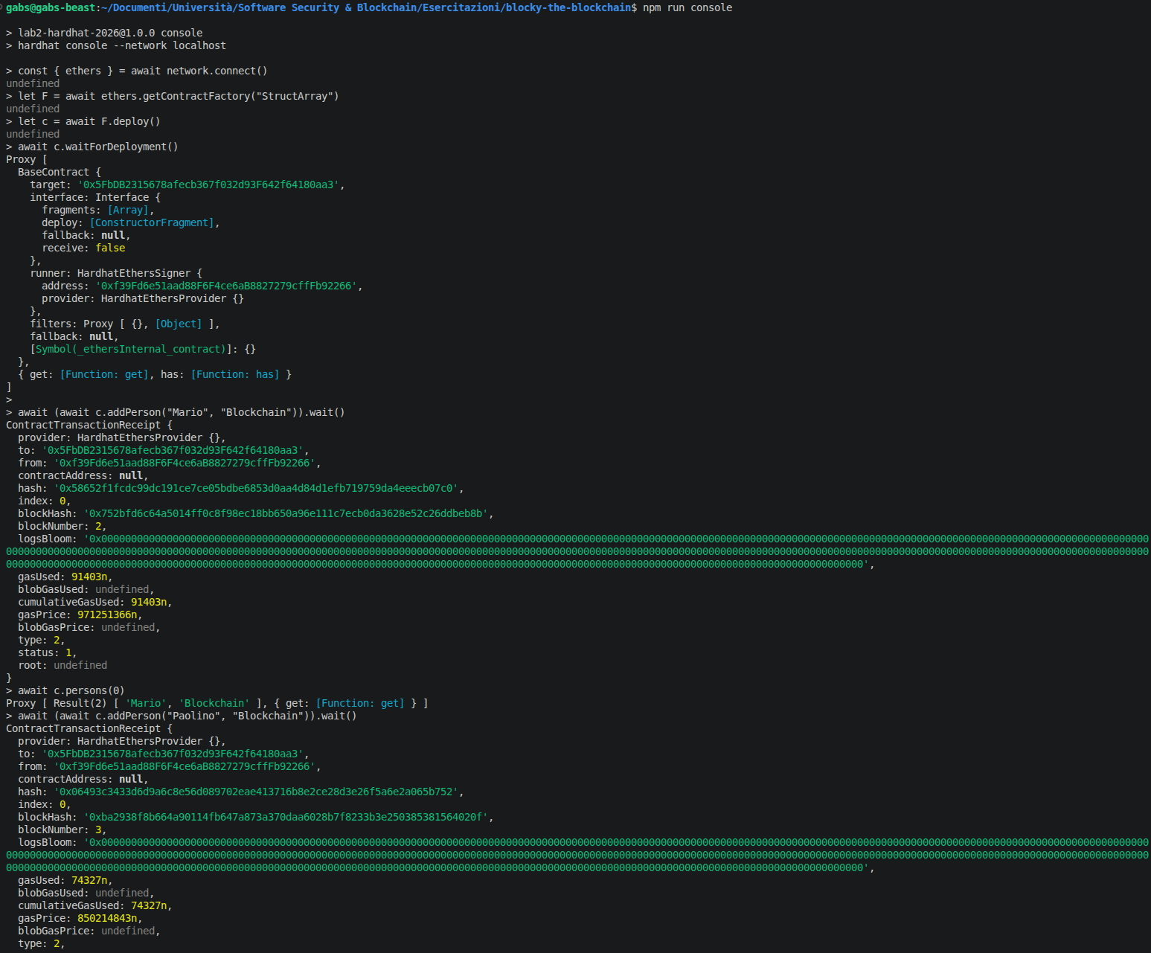
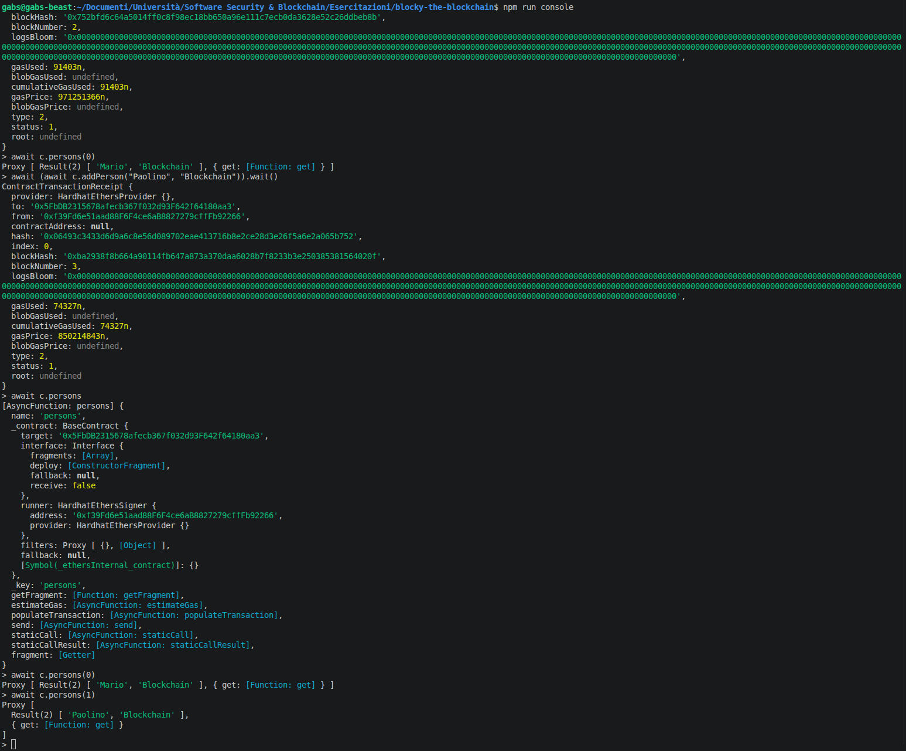
- Create and manage nested structures using a contract.
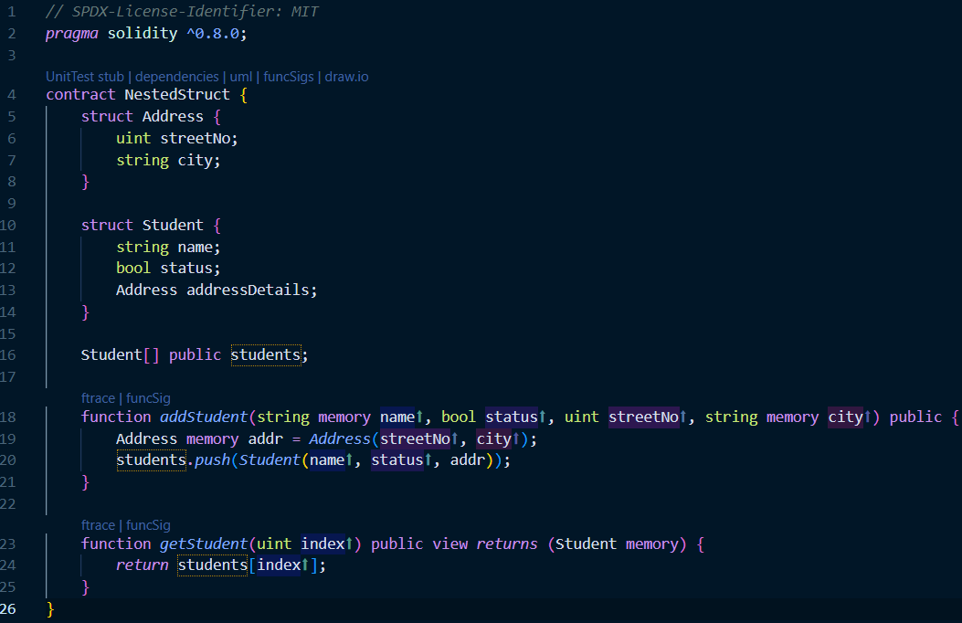
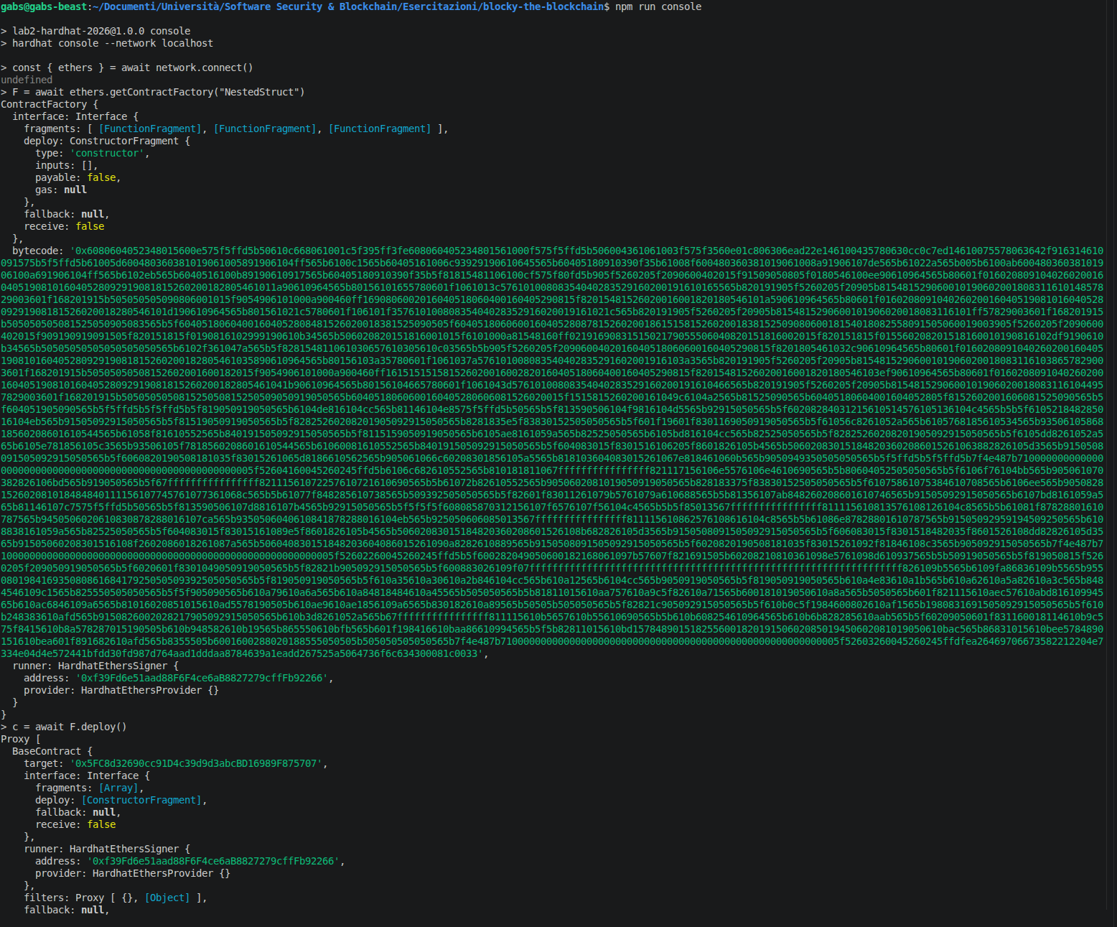
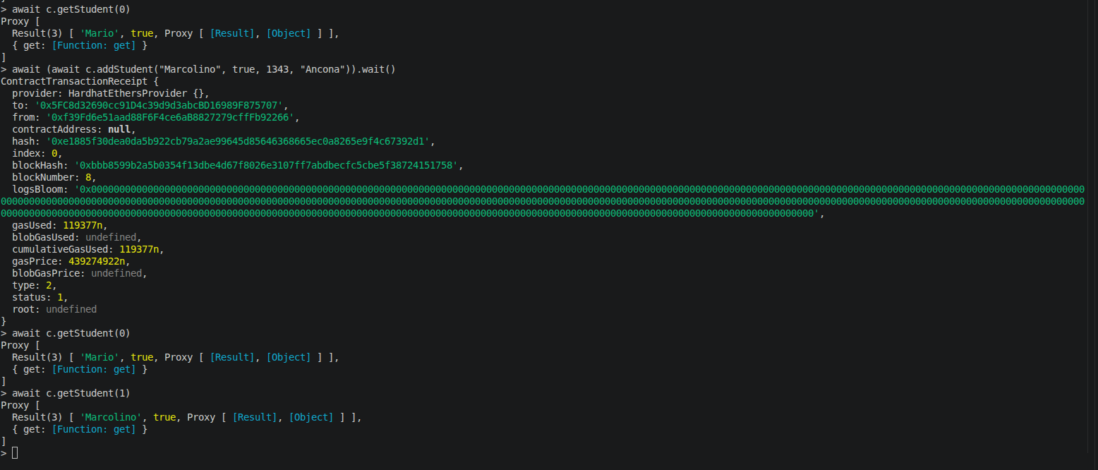

- Combine nested structures with mappings to manage data efficiently.
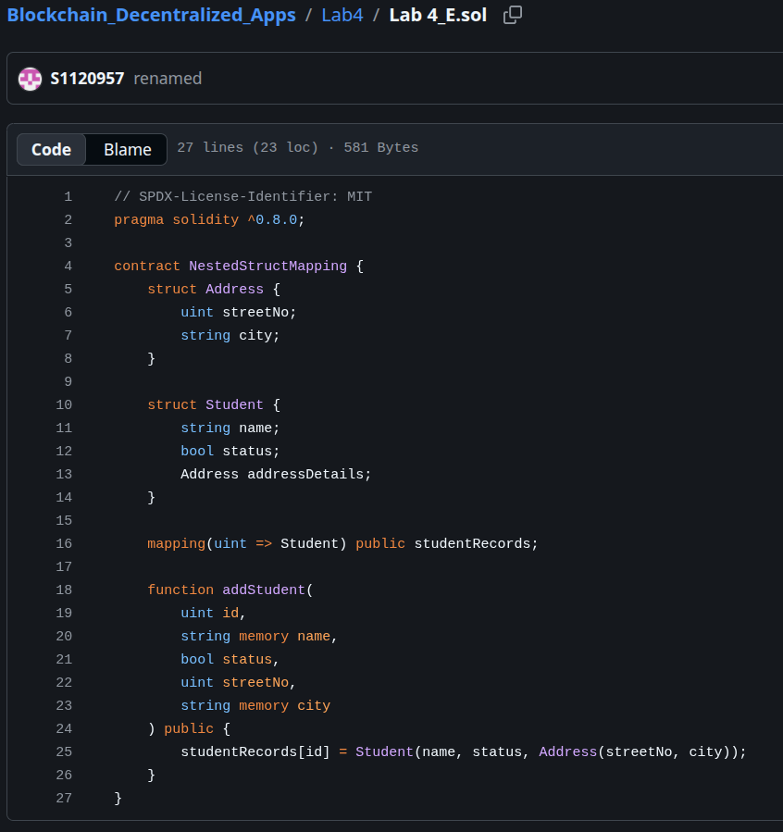

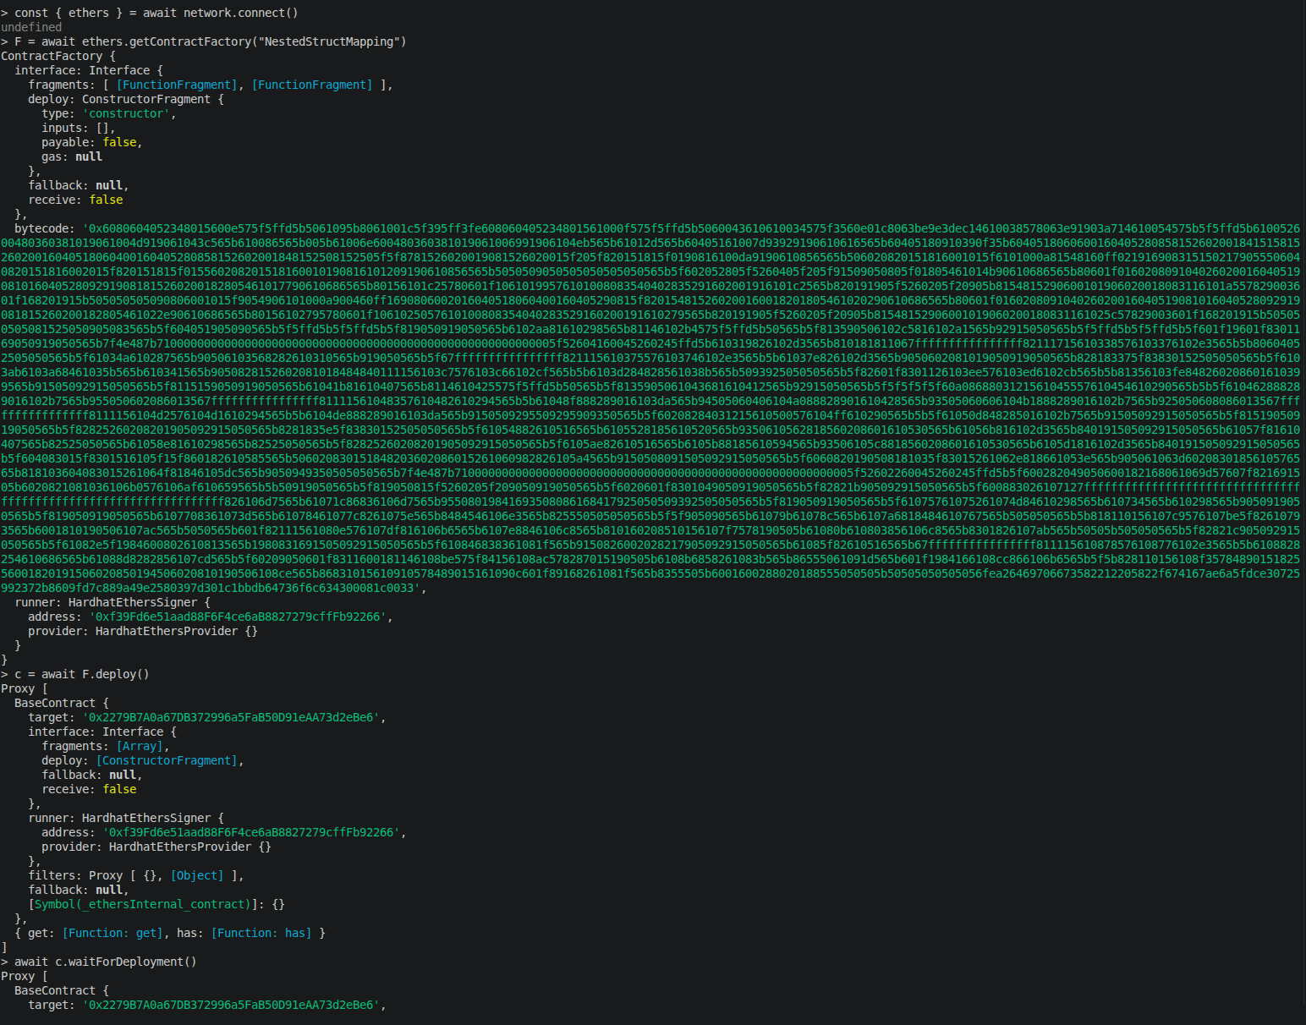
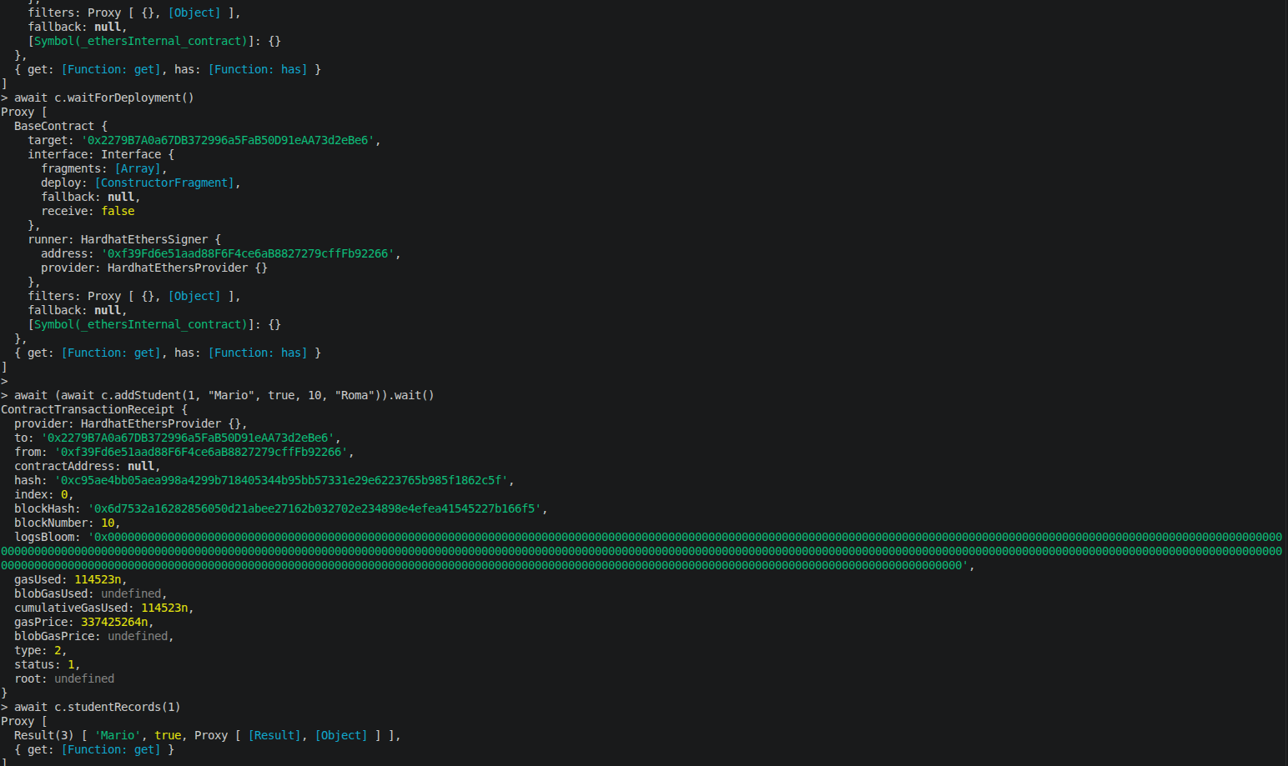

Lab Tasks
- Simulate a ticket booking system using mappings and structs. Also, use require, assert and revert for error handling.
Contract:
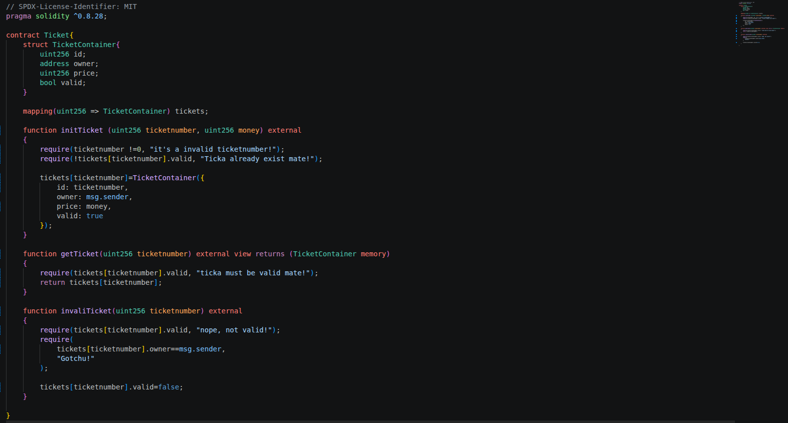
Result:
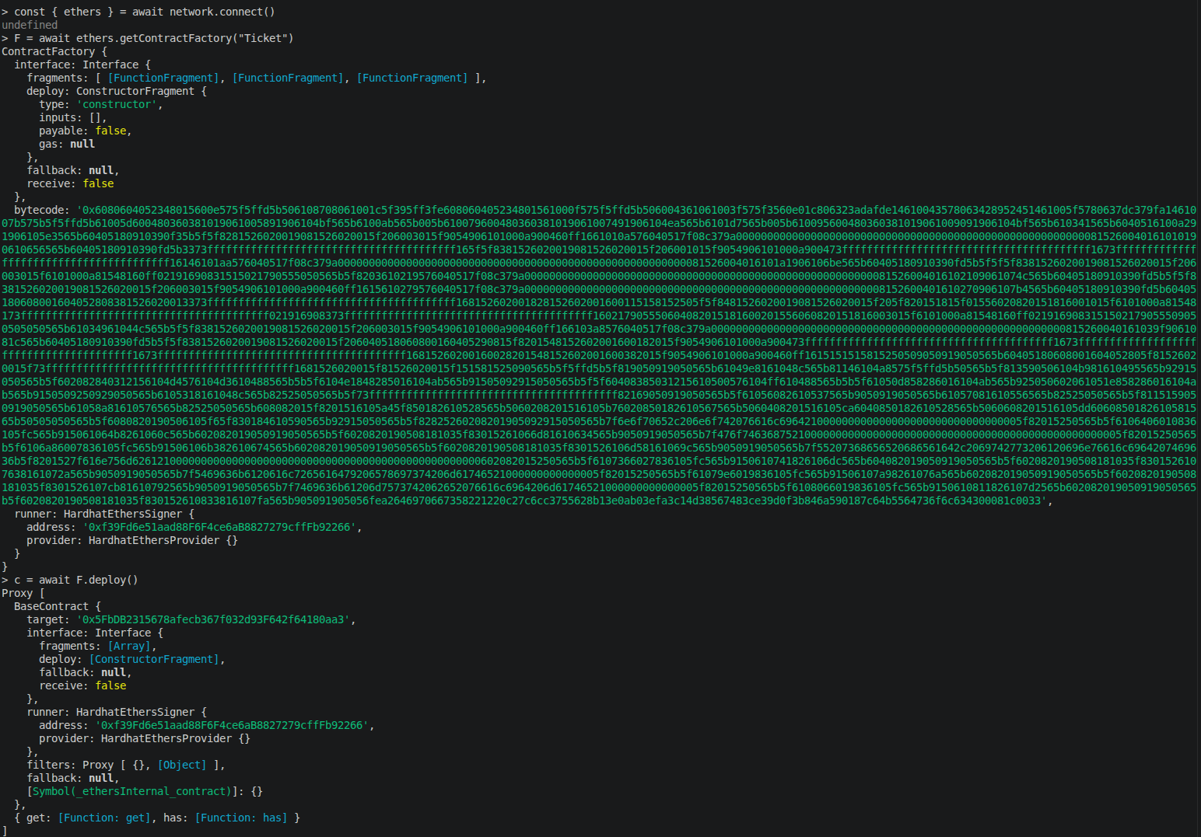
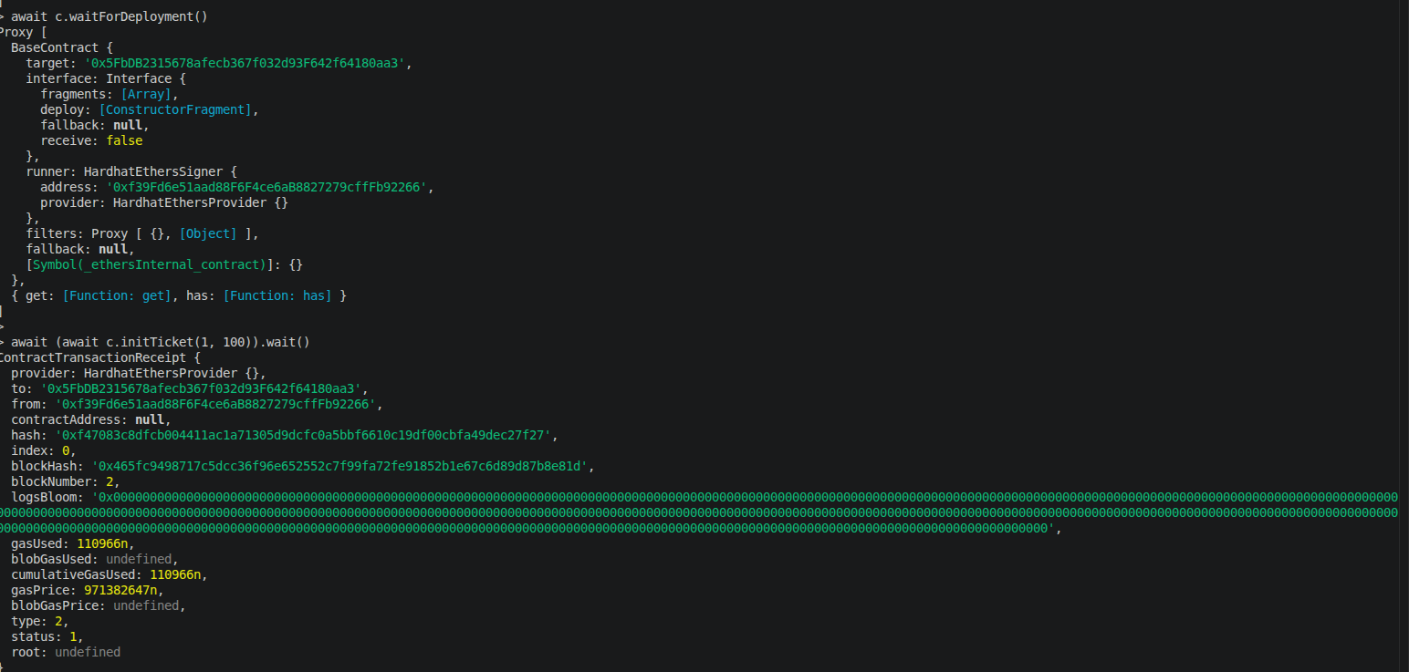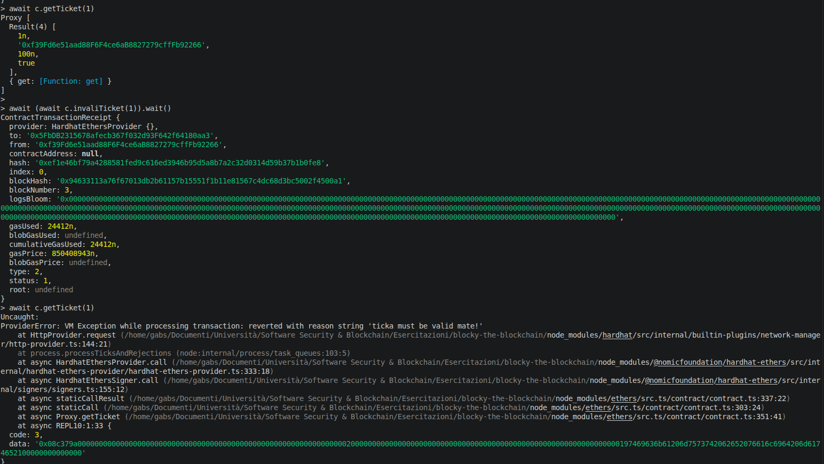
Blockchain out:
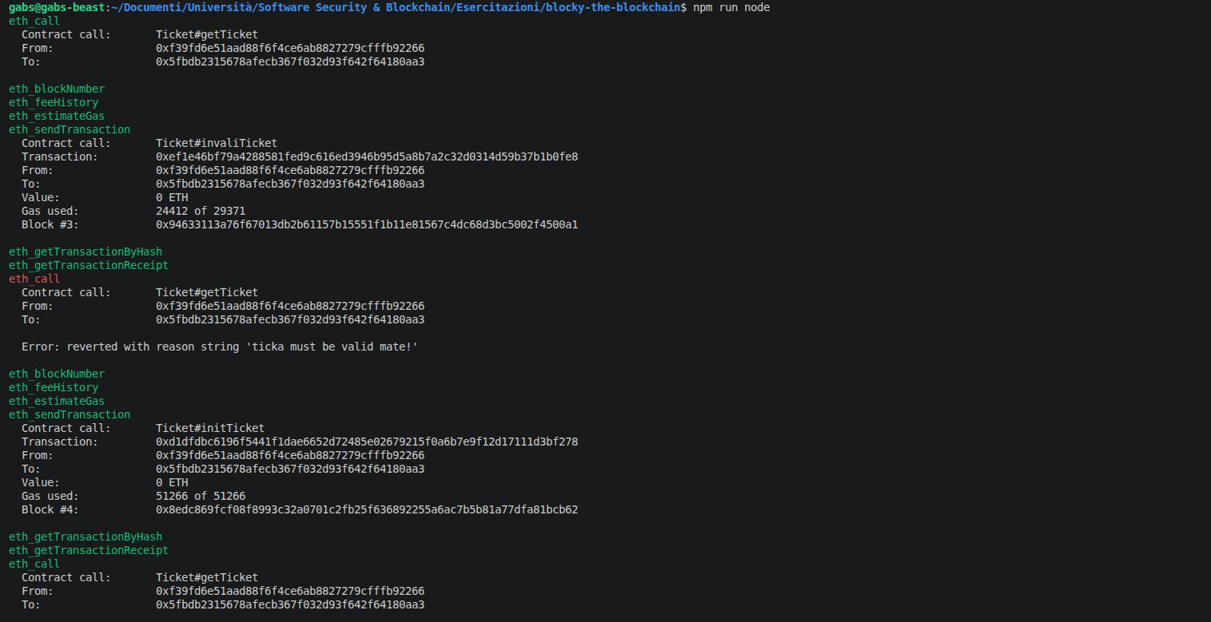

- Create a nested structure to manage an online shopping cart, where each item includes its name, price, and a nested shipping address.
Code:
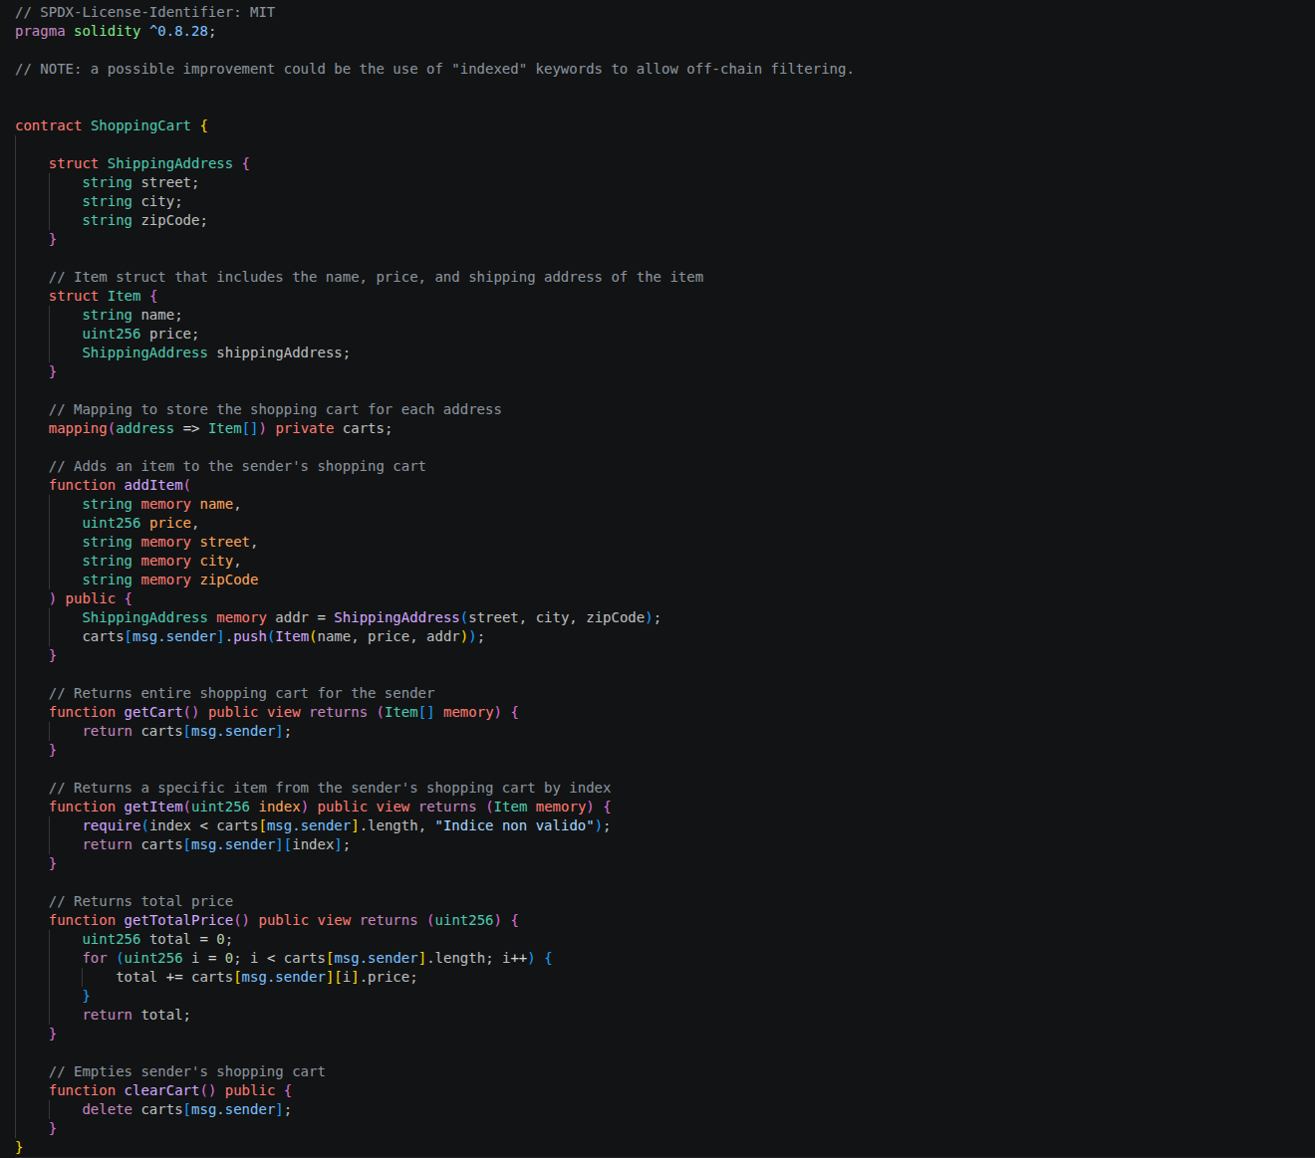
Results:


